- HOME NETWORK DIAGRAM
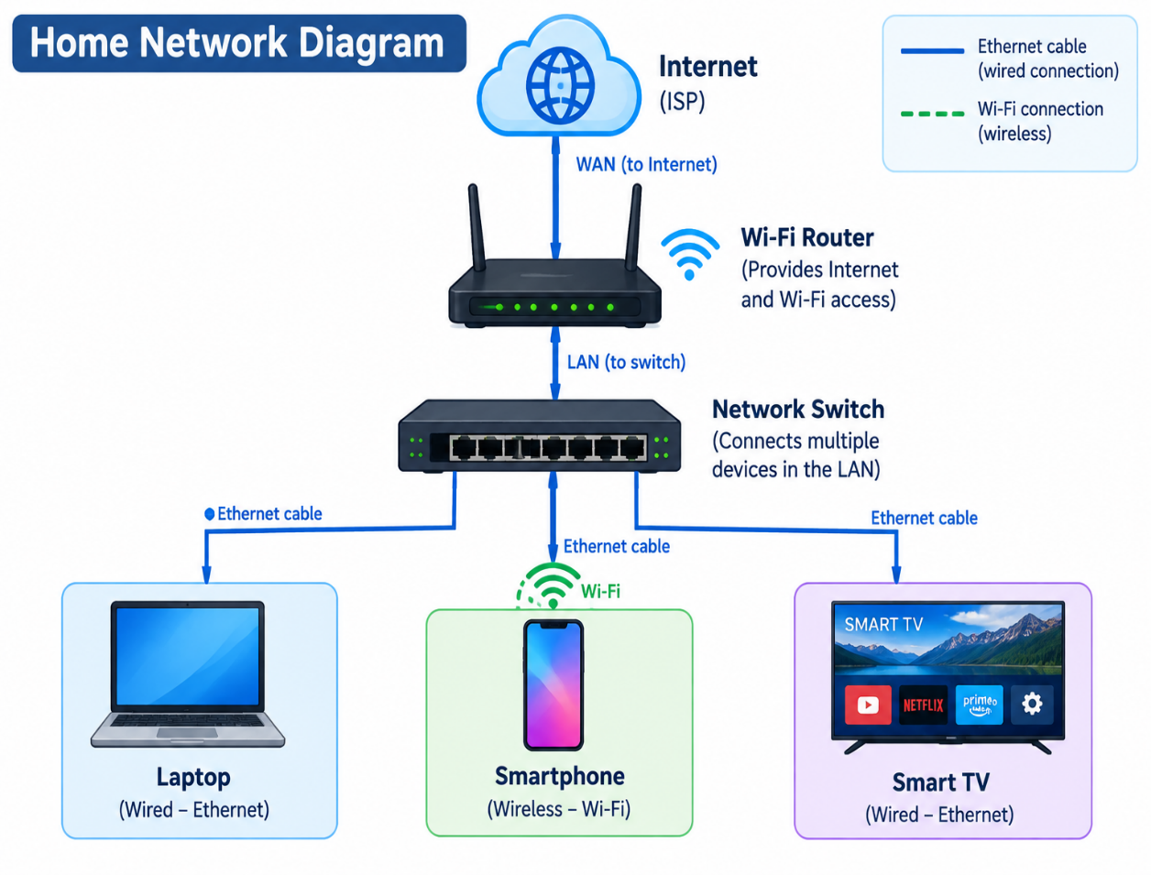

2. Comparison of Network Devices
Network Device | Main Function | Real-World Use Case
Router | Connects different networks and routes data. | Connects home devices to the Internet for Zomato orders.
Switch | Connects multiple wired devices in a LAN. | Connects gaming PCs for LAN gaming.
Hub | Sends incoming data to all connected ports. | Used in older, simple LAN setups for basic device connectivity.
Access Point (AP) | Provides Wi-Fi connectivity to wireless devices. | Connects smartphones to Wi-Fi for YouTube streaming.

- How Data Travels When Ordering Food on Zomato:

- I open Zomato on my smartphone and place a food order.
- The phone sends the request through Wi-Fi to the router's access point.
- The router forwards the request to the Internet through my Internet Service Provider (ISP).
- Switches in the network forward data between connected network devices as it travels toward Zomato's servers.
- Zomato processes the order and sends a response back through the Internet and router to my phone.

4. Connecting a Gaming PC Far From the Wi-Fi Router :

Option 1: Wi-Fi Extender with an Ethernet Port
- The extender receives the router's Wi-Fi signal and provides an Ethernet port for the gaming PC.
- It avoids running a long Ethernet cable, but speed depends on Wi-Fi signal strength
.
Option 2: Powerline Adapter
- One adapter connects to the router using Ethernet, and another connects to the gaming PC.
- The adapters carry network data over the home's electrical wiring, so performance depends on the wiring and electrical conditions.
Recommendation: Use a powerline adapter if the Wi-Fi signal is weak in the gaming room and the home's electrical wiring supports a reliable connection. A direct Ethernet cable is also an excellent option if practical.

